**CSIR-EPIC 2024**

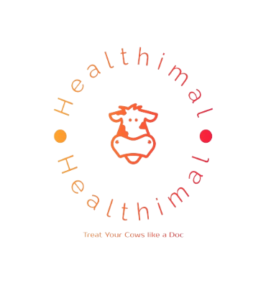

Team Healthimal

**Abstract:**

**Agriculture is important in our nation, and cattle rearing is an occupation for many. Cattle, like us, also get diseases, and rearers may not know what to do and may probably get the disease. Hence, we have created an app which will detect diseases in cattle and give supportive care and taking precautions. In severe cases, the app advises the rearer to contact a professional and locates nearby veterinary care centers.**

**INTRODUCTION:**

**In the ever-evolving landscape of agriculture, the importance of effective animal management and disease diagnosis cannot be overstated. As we strive to meet the growing demands of a burgeoning global population, optimizing practices in animal husbandry becomes crucial for sustainable and efficient agricultural systems. This report delves into the intricate realm of animal management and disease diagnosis, exploring innovative strategies and technologies that promise to revolutionize the way we care for our livestock.**

**PRINCIPLE:**

**The app has a variety of languages to chose from. It identifies the disease using AI to identify the disease by the symptoms entered by the user and recommends supportive care to the animal. In cases where supportive care only is not enough, it gives an option to contact a professional veterinarian and also locates nearby veterinary centers where the animal may be given treatment.**

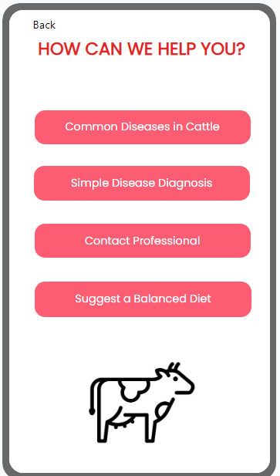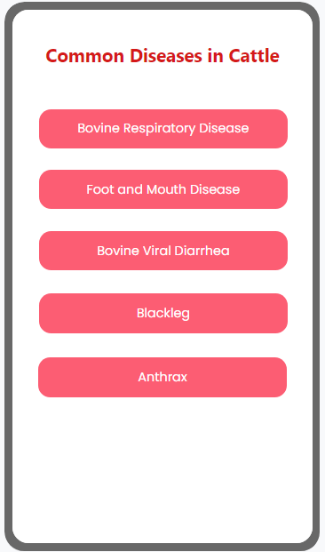

**APPLICATION:**

**The applications of this app include disease monitoring like tracking and monitoring health status of individual cattle or herds, allowing early detection of potential diseases.**

**It offers diagnostic support like offering information and resources for common symptoms, aiding farmers and veterinarians in diagnosing potential diseases.**

**It also educates users on bio-security measures to prevent spread of diseases within and between farms.**